***PRJ301 CLASS SE1714-06***

**Project: Jackets Online Shop (Web bán áo khoác)**

**Members:**  Đinh Gia Huy

Nguyễn Xuân Kha

Lại Nguyễn Minh Quân

**PRODUCT DESCRIPTION**

1. **REQUIREMENT:**
2. Name of system: Selling jackets online shop
3. Purpose: This project aims to provide consumers with jacket products
4. Who use this system: aim to adult people from 16-3x years old
5. List all feature:

-See/Add/Modify/Delete information of products/ customers/ providers

-Search/ sort product by name

-Save/delete customer’s orders

-Login

-Blog

-View gallery

Admin:

-See/Add/Modify/Delete information of products/ customers/ providers

-Search/ sort product by name

-Save/delete customer’s orders into database

-Manage customer’s account

-Share blog

-Export customer’s order to barn

User:

-See information of products/ providers

-Search/ sort product by name

-Make orders

-Comment

-Login

-View Blog

-View gallery

**2. UI WEB TARGET DESIGN:**

1. Main page:

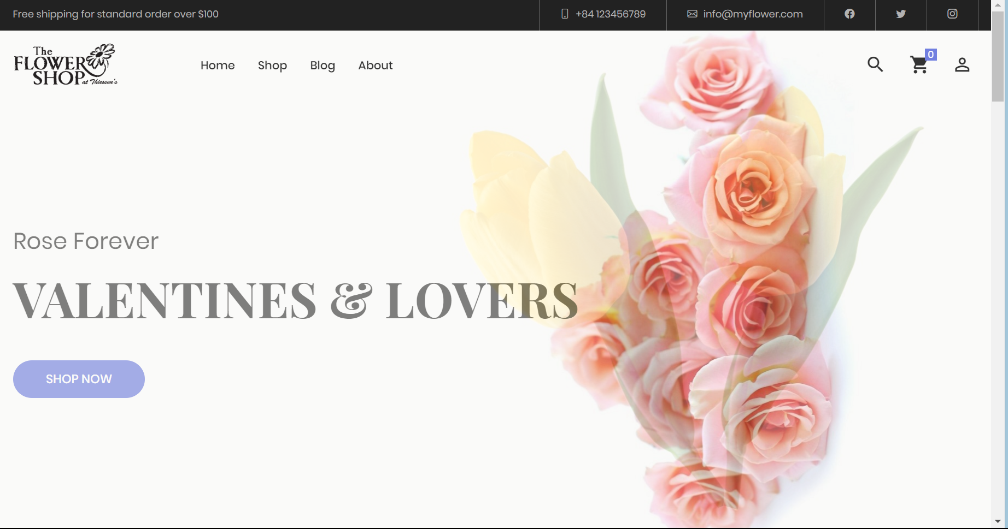

1. Address page

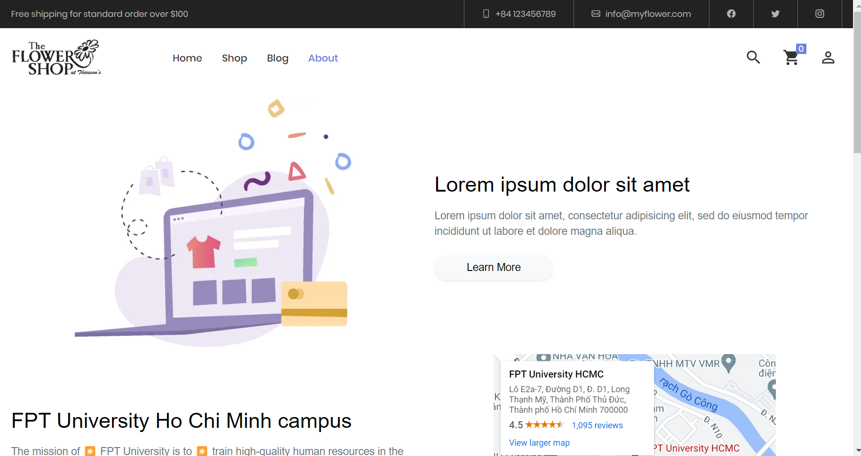

1. Products store

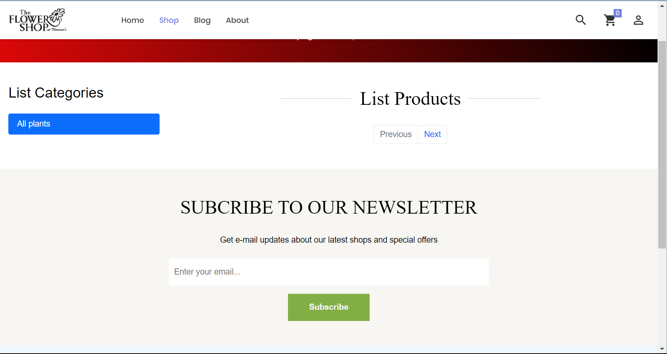

1. Cart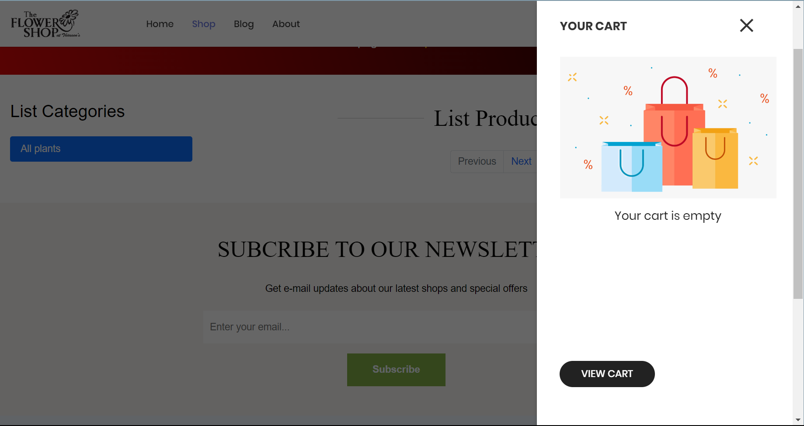
2. Address bar

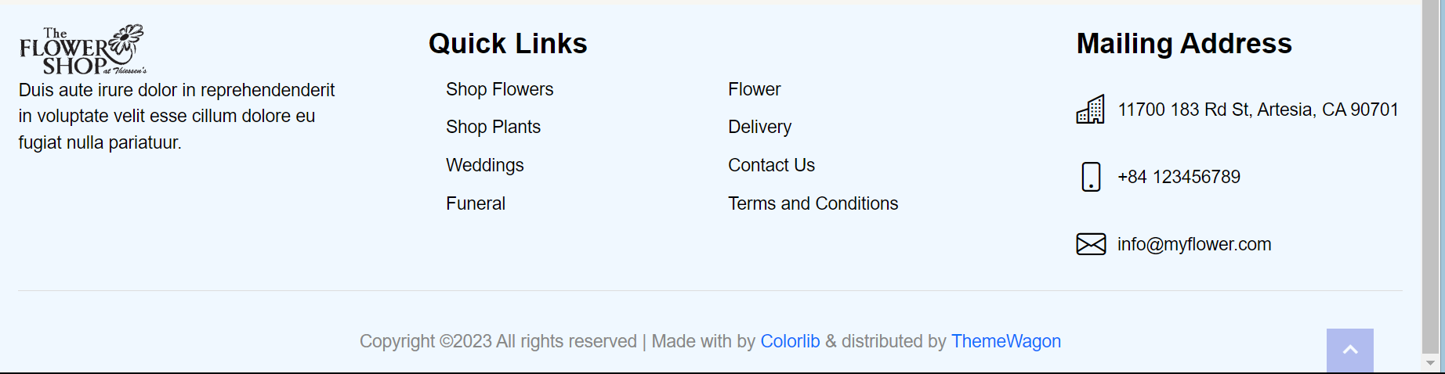

**[Hope]**

**[Project Name: Selling Jackets Online Shop]**

[Date]

Project Overview:

The purpose of this document is to provide an overview and outline the key details of the project "Selling Jackets Online Shop" undertaken by Hope. This project aims to establish an online platform for selling jackets to customers worldwide, providing them with a seamless and enjoyable shopping experience.

1. **Project Objectives:**

a. Create an attractive and user-friendly website that showcases the jackets available for purchase.

b. Develop a secure and efficient online shopping cart system for customers to add jackets and make purchases.

c. Implement a robust inventory management system to track the availability of jackets and manage stock levels.

d. Incorporate customer reviews and ratings to enhance credibility and facilitate informed purchases.

e. Integrate a customer support system to address queries, concerns, and provide assistance when required.

1. **Project Scope:**

a. Website Development:

* + Design a visually appealing website with a user-friendly interface.
  + Create product pages for each jacket, including detailed descriptions, high-quality images, and pricing information.
  + Implement a search functionality for customers to easily find jackets based on various criteria.
  + Ensure mobile responsiveness for an optimal browsing experience across different devices.

b. Shopping Cart System:

* + Develop a robust shopping cart system that allows customers to add jackets, update quantities, and proceed to checkout.
  + Implement a secure login and registration process for customers to create accounts and track their orders.
  + Incorporate guest checkout functionality to accommodate customers who prefer not to register.

c. Inventory Management:

* + Implement an inventory management system to track jacket availability and stock levels.
  + Enable automatic updates to reflect real-time inventory status.
  + Set up notifications to alert administrators when stock levels are running low.

d. Customer Reviews and Ratings:

* + Enable a review and rating system to allow customers to share their feedback and experiences.
  + Implement moderation features to ensure authenticity and prevent spam or inappropriate content.
  + Display reviews and ratings prominently on the website to help potential customers make informed decisions.

e. Customer Support:

* + Set up a customer support system, including contact forms, live chat, or a dedicated support email address.
  + Train support staff to promptly respond to customer queries and concerns.
  + Implement a ticketing system to track and resolve customer issues effectively.

1. **Project Timeline:**

The project timeline will be divided into several phases, with specific milestones and deliverables. Here is a high-level overview:

* + Phase 1: Planning and Requirements Gathering
  + Phase 2: Website Design and Development
  + Phase 3: Shopping Cart System Implementation
  + Phase 4: Inventory Management Implementation
  + Phase 5: Customer Reviews and Ratings Integration
  + Phase 6: Customer Support System Implementation
  + Phase 7: Testing and Quality Assurance
  + Phase 8: Deployment and Launch

1. **Project Team:**

The project team will consist of the following members:

* + Project Manager: Responsible for overall project coordination, timeline management, and communication.
  + Web Designer: Responsible for creating an attractive and user-friendly website design.
  + Web Developer: Responsible for implementing the website's functionality and integrating various systems.
  + Quality Assurance Specialist: Responsible for testing and ensuring the website's quality and functionality.
  + Inventory Manager: Responsible for managing inventory and ensuring real-time updates.

By adhering to this project plan, Hope aims to establish a successful online shop for selling jackets, offering customers a convenient and satisfying shopping experience.